Name of Church

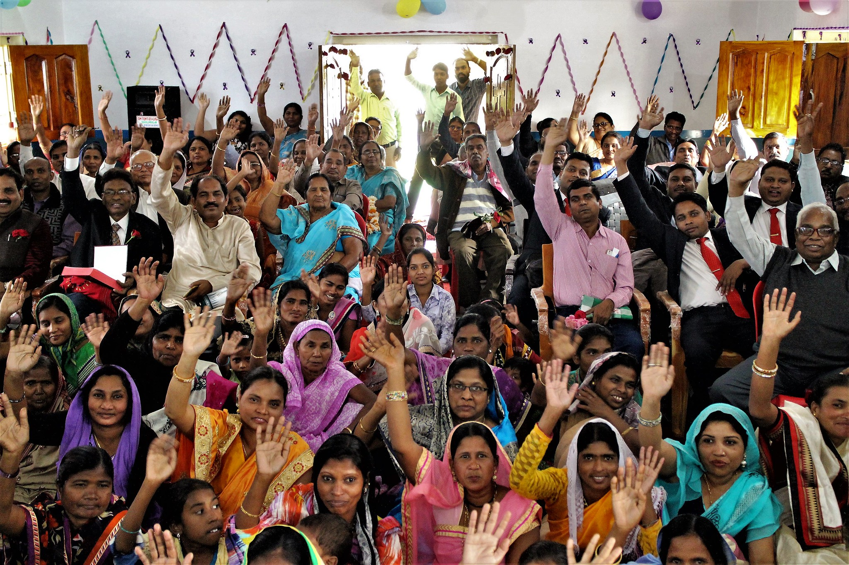
Photo: Henk Stenvers

Following Jesus together
across barriers
Worship Together:
Celebrate our Anabaptist Movement
Anabaptist World Fellowship Sunday

Date 2021

