[Name of Church]

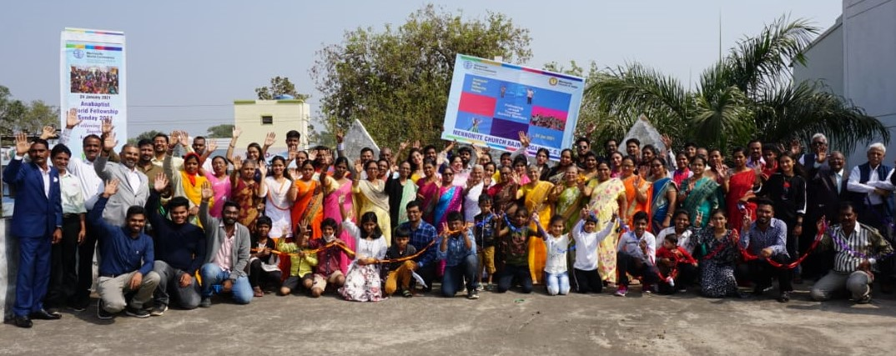
Photo: Vikal Rao
Rajnandgaon Mennonite Church celebrates AWFS in 2021

Following Jesus together

Worship together:
Celebrate our Anabaptist movement
Anabaptist World Fellowship Sunday

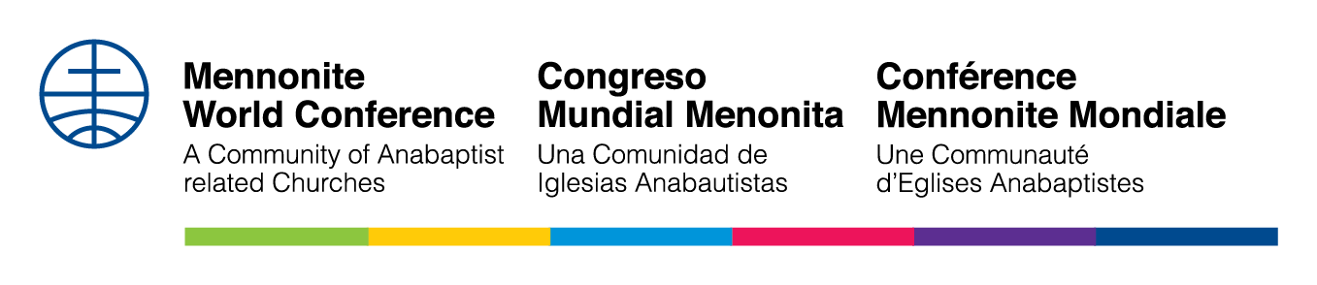

[Date] 2022
[Name of Church]

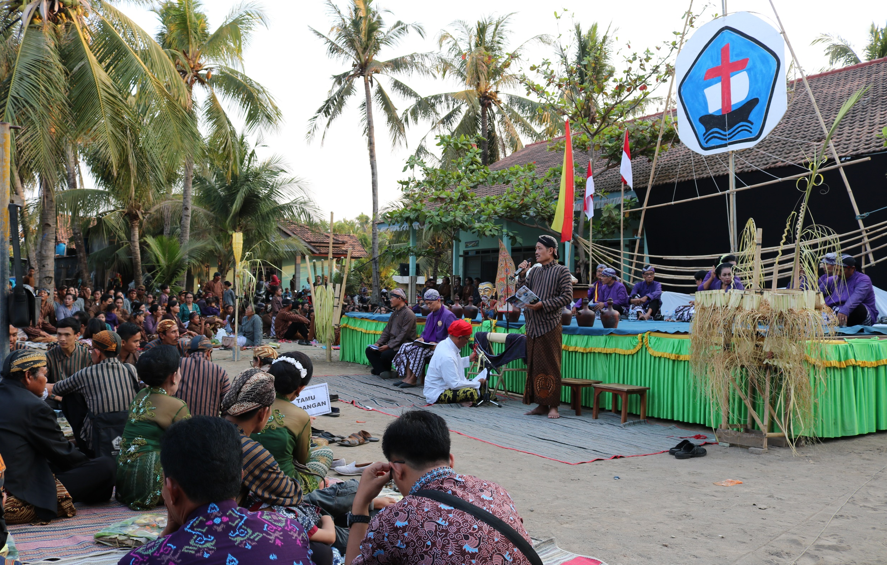
Photo: Karla Braun
A celebration of the GITJ congregation in Banyutowo,
Central Java, Indonesia, in 2019

Following Jesus together
Worship together:
Celebrate our Anabaptist movement
Anabaptist World Fellowship Sunday
[Date] 2022
[Name of Church]
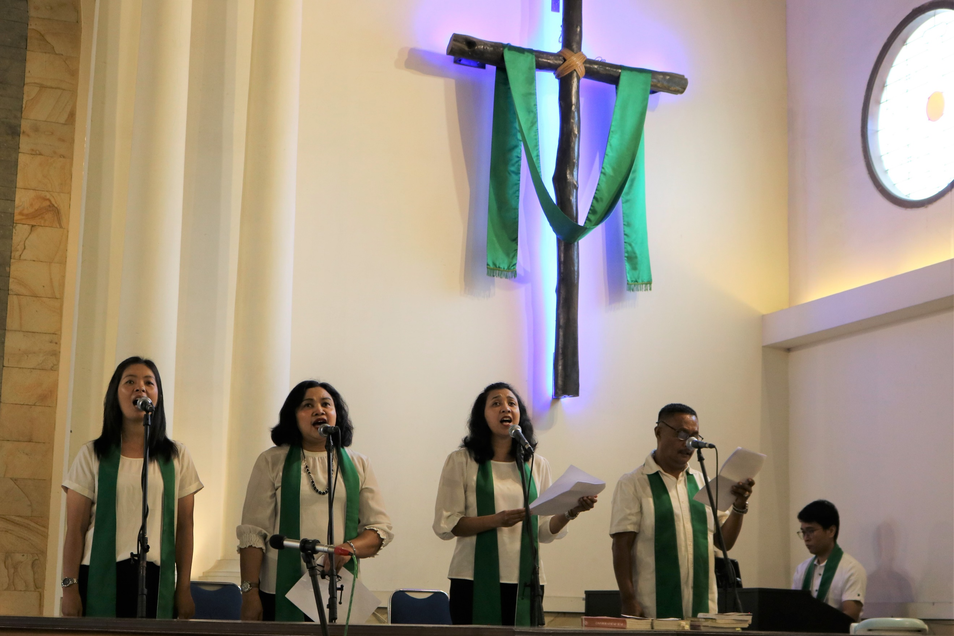
Photo: Karla Braun
Song leaders at a GKMI congregation in Salatiga, Indonesia,
in 2019

Following Jesus together
Worship together:
Celebrate our Anabaptist movement
Anabaptist World Fellowship Sunday

[Date] 2022

